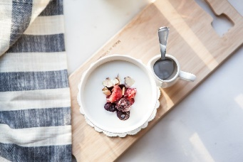
Eating well while working at home
DO:
- Decrease your portions and eat 10-15% less of what you usually eat.
- Stick to an eating routine that includes 2-3 healthy meals/day and 1-2 healthy snacks according to your needs and eating habits
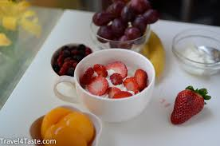
- Snack of vegetables and fruits. You can also snack on Edamame (whole, immature soybeans), which have more calories than vegetables, but provide also more proteins and is a portion of healthy food. Keep your portion moderate.
- If you snack on nuts and seeds, keep your portions small (2 Tbsp./day)
- Pay attention to the food that you eat. Set a limit to the total amount of food you eat in a day and eat 10-15% less of what you usually eat.
- If you know how to count calories, do so, and set an upper limit.
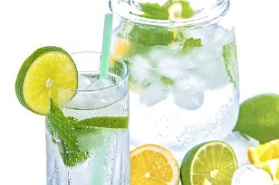
- Stay hydrated by drinking water and/or herbal teas (be aware that certain herbal teas, like chamomile, could interfere with some medications; call your pharmacist).
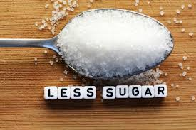
- Drink in moderation coffee and tea that may contain caffeine. Flavour it with milk or small amounts of cream, and learn to drink it with little or no sugar.
  - Drink no more than 3 cups of coffee/day
  - Drink no more than 6 cups of caffeinated tea/day
AVOID:
- Avoid eating high-calorie snacks; if you eat them, keep your portion very small. It is better to avoid buying it.
- Stay away from sweetened beverages, such as pop, juice, or sweetened coffee or tea.
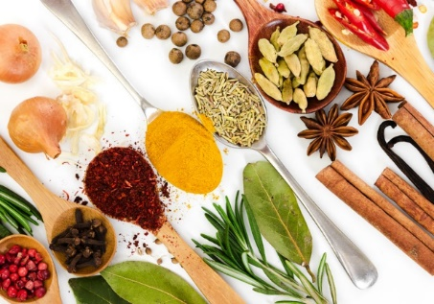
- Don’t add too much fat to your cooking, measure the amount of oil or fats when you cook: 1 tsp. of oil per person is a good guide. Use herbs and spices instead, to give flavour to your food.
- Avoid using too much butter, margarine, mayonnaise, salad dressings, cream, etc. Keep your portions small; 1-3 tsp. of fat per person is a healthy guide. Fats are foods that have many calories concentrated in very small amounts; one teaspoon of fat has 45 calories, almost the same amount of calories contained in an orange.
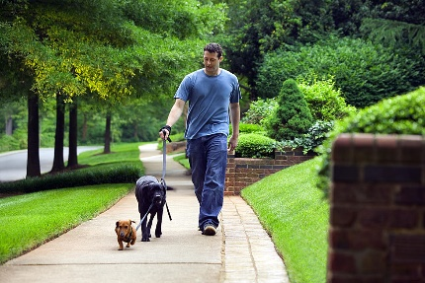
- Avoid using too much sugar, such as jam, marmalades, maple syrup, or honey. Keep your portions small; 1-3 tsp. of sugar per person is a healthy guide.

PHYSICAL ACTIVITY:
DO:
- Use your breaks to go for a walk. Remember: any exercise is better than none.
- Schedule a longer walk during your lunch hour, or before starting or after finishing your work schedule.
- Stick to an exercise routine and keep a log to notice how successful you are.

MINDFULNESS:
DO:
- Eat your meals at the table when possible, and try to enjoy them.
- Keep yourself well hydrated with water. Sometimes we mistake hunger with being thirsty; we may think that we are hungry which in reality we may be thirsty. Aim for 8-12 cups of water per day.
- Avoid eating in front of a screen; if you do so, take a minute to visualize what you have put in your plate and be aware of what you are eating; it is like taking a mental picture of your meal, so you can remember later what you ate.
- Treat food according to its kind. Healthy foods:
  - Vegetables and fruits can be eaten at any time, they are low in calories and packed with healthy nutrients.
  - Dried fruits are also healthy, but contain more calories than fresh fruits. Keep your portion small.
  - Healthy fats, such as nuts, seeds, avocado, canola oil, olive oil, etc. provide essential nutrients, but are packed with calories; keep your portions very small.
- Unhealthy snacks:
  - Try to avoid them. Eating small portions is the key. You may want to try this trick: drink 1-2 cups of water and eat a fruit or a vegetable first, and then serve a small portion of an unhealthy snack. In this way, you may be eating less amount. When you finish what you have, try not to buy them again.
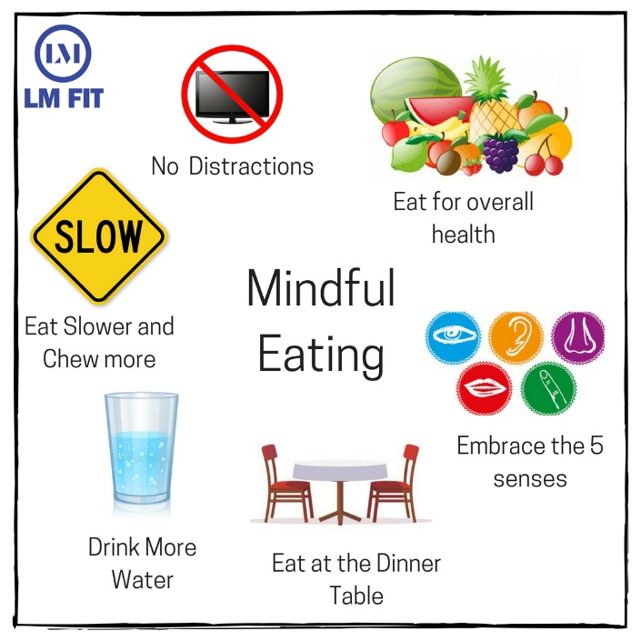

TOP 10!
- Eat healthy foods
- Eat a little bit less to avoid gaining weight, since you may be less active
- Weigh yourself once a week and act promptly if you gain weight
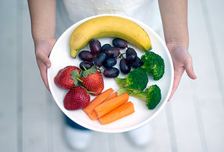
- Keep a regular eating schedule, trying to have 2-3 healthy meals/day, and making sure you don’t go without food for more than 5-6 hours on a row
- Snack only if you have missed a meal. If you snack, drink 1-2 cups of water first and then snack on vegetables and fruits
- Keep yourself hydrated, and drink water or decaffeinated tea at your desk
- Make an effort and avoid bringing food to your desk
- Take a few minutes to eat at the table
- Stay active: If able, go for a walk during your lunch hour, or use an exercise machine if you have it. Go for a walk or clean your house during your breaks, to increase your physical activity
- Make a plan: at the beginning of the day or the night before making a plan that includes 2-3 healthy meals, and healthy snacks should you find yourself hungry. Make sure you also plan to do some physical activity every day. Adjust your plan if you need to. Soon you’ll have a fit lifestyle plan to keep yourself healthy and in good physical shape.
Stay safe.
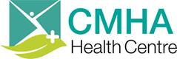
Remember:
Eat enough, eat healthy, and drink plenty of fluids.

